**Software Requirement Specification**

*for*

ProjectName : “Blog Functionality”

*created from:*

*With members :*

*Jordan Petkov – Junior QA*

*Gergana Suvandzhieva – Junior QA*

[*Dimitar*](https://www.facebook.com/zahariq.pehlivanova?fref=pb_other) *Dimitrov – Junior QA*

*Jordan Mihailov – Junior QA*

*Tsvetelina Gogova – Junior QA*

*Ilian Panchev– Junior QA*

*Valeria Savova– Junior QA*

CONTENTS……………………………………………………….............page

1. Introduction……………………………………………………………………...3
   1. Purpose……………………………………………………………….......3
   2. Scope of project…………………………………………………………..3
   3. Constrains…………………………………………………………………3
2. Overall description
   1. Vocabulary…………………………………………………………………3
   2. Game View and Description…………………………………………........4
   3. “How it Work” Block Scheme……………………………………………..5
   4. Non-functional Requirements……………………………………………..6
   5. Functional Requirements………………………………………………7÷10
3. **Introduction**
   1. ***Purpose***

The main purpose of this document is to describe in details what is the exact functionality, how the system will work properly, what needs to be done for improving the system. This document is prepared to help developers and stakeholders to understand in depth the project.

* 1. ***Scope of Project***

Team “PassionFruit” will develop and present a blog named “SoftUni Blog – Web App”. It is discussion or information website, consisting of structured, informal diary-style text arias named “posts”. It will be used from SoftUni students for posting topics of any kind related with the university life.

Every student must have registration for posting in the blog. After login he/she will have the option to post, edit and delete his/her own blog posts. Guest users can only read the posts.  
  
***1.3*** ***Constrains***

* The project must be started at any Windows, OSX, Linux PC as well as Android, iOS and Windows Phone with a modern web browser.
* You need a Internet connection to get into the blog.

1. **Overall Description**
   1. **Vocabulary**
      1. **Main Page** – This is the place where all the blog post will be displayed. There will be links for registration and login in the blog. Not registered users will not allowed to write posts.
      2. **User –** anyone, who enter the Home page of the Blog
      3. **Registered User –** anyone, who has registration in the Blog. Registered user can write, edit and delete his own posts.
      4. **Login Page** – Page for login existing users.
      5. **Registration page –** Page for new user registration.
      6. **Registered User Manage Info –** Page for change registered user credentials.
      7. **Registered User Change Password –** Page for change registered user password.
      8. **Article Details page –** Page for reading full post
      9. **Edit Article page –** Page for editing the blog post
      10. **Delete Article page –** Page for editing the blog post
      11. **Registered User Manage Info page –** Page for editing own information
      12. **Registered User Change Password page –** Page for changing user password
      13. **Blog topic page –** Full content of the blog topic.
   2. **Blog View and Description**

In the **Home page** of the blog you will see header with logo and two buttons – Register and Login. On the main div will be loaded the posts in blog. Every post will have Title, blog post and author. In the footer will be copyright info.

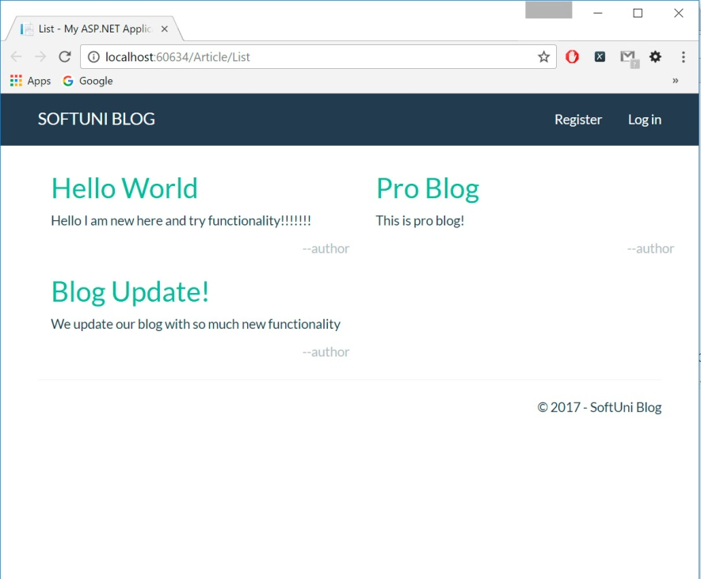

**Register page** will have form for registration with this fields – Email, Full Name, Password, Confirm Password. Will be not allowed two users with the same username. The form will check for vali­d email and password before registration.

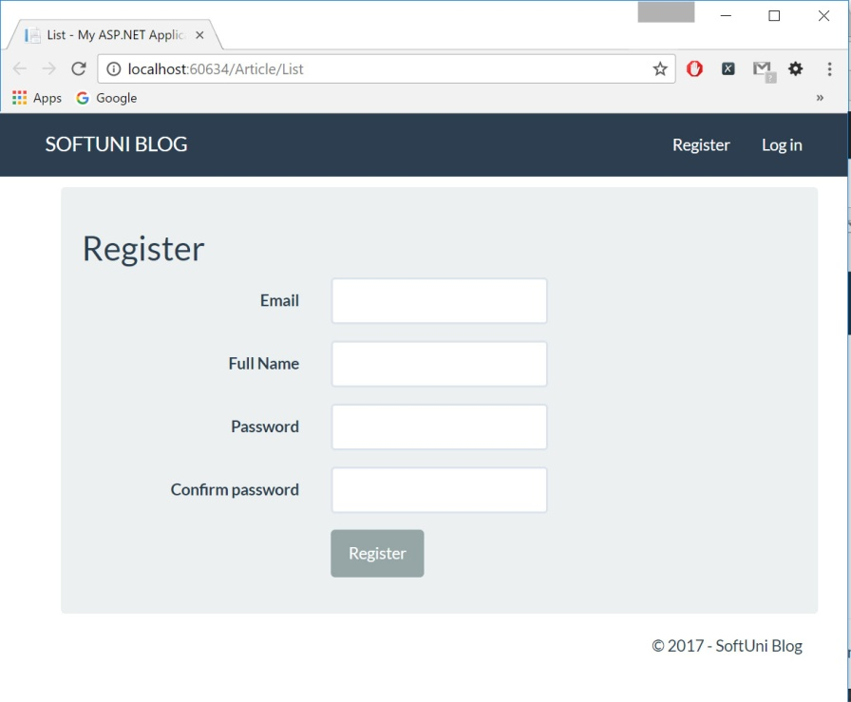

**Login page** will have form for login with two fields: Email and password. When registered user input correct email and password will be allowed to write blog posts.

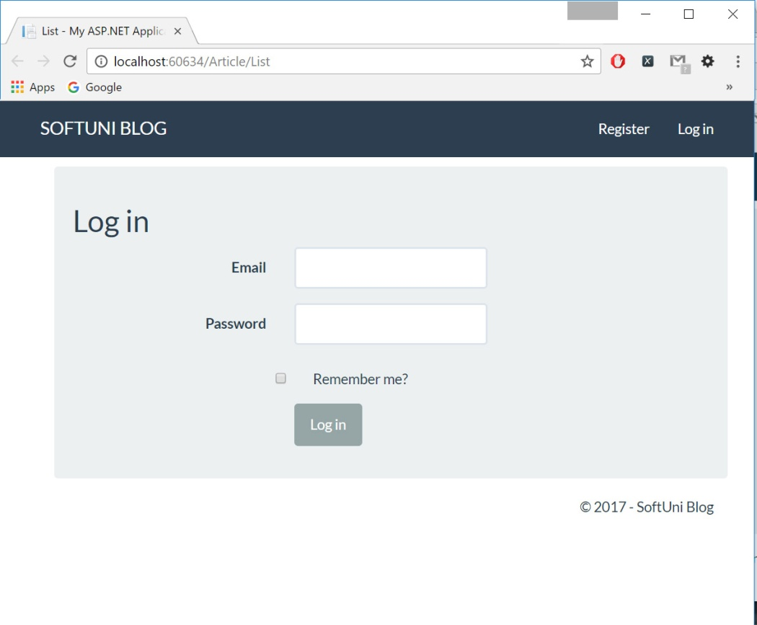

**Article Details page** will contain full blog post from the Home Page. Under the blog post there are two buttons – Edit and Delete. If user is logged in and is the author of the post it will have the rights to edit or delete the post.

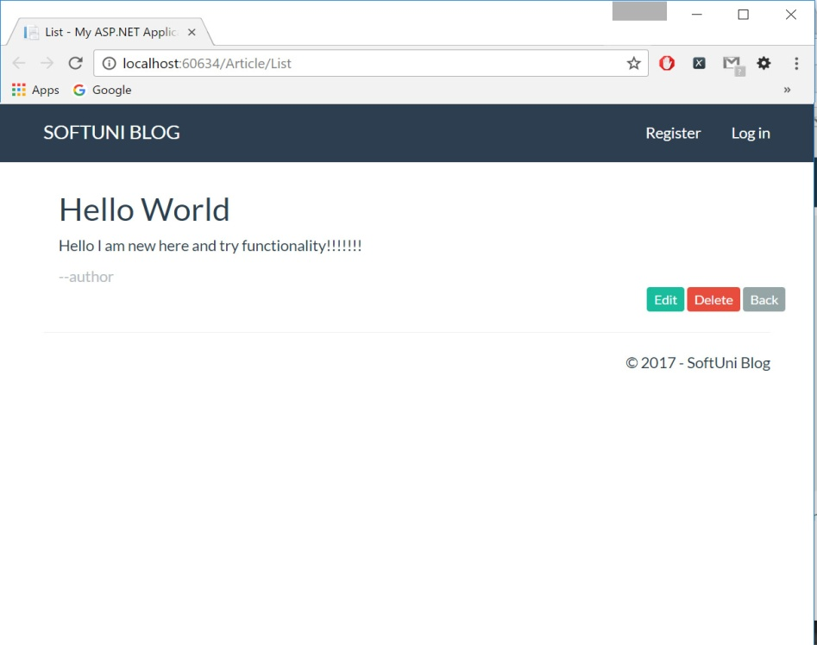

**Edit Article page** will contain the blog post that will be edited. Under the blog post there are two buttons – Cancel and Edit. If user is logged in and is the author of the post it will have the rights to edit the post.

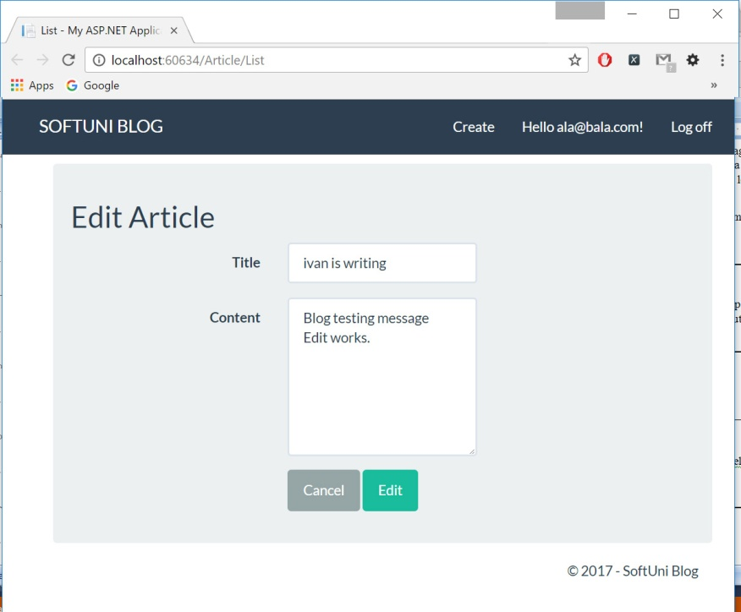

**Delete Article page** will contain full blog post from the Home Page. Under the blog post there are two buttons – Cancel and Delete. If user is logged in and is the author of the post it will have the rights to delete the post.

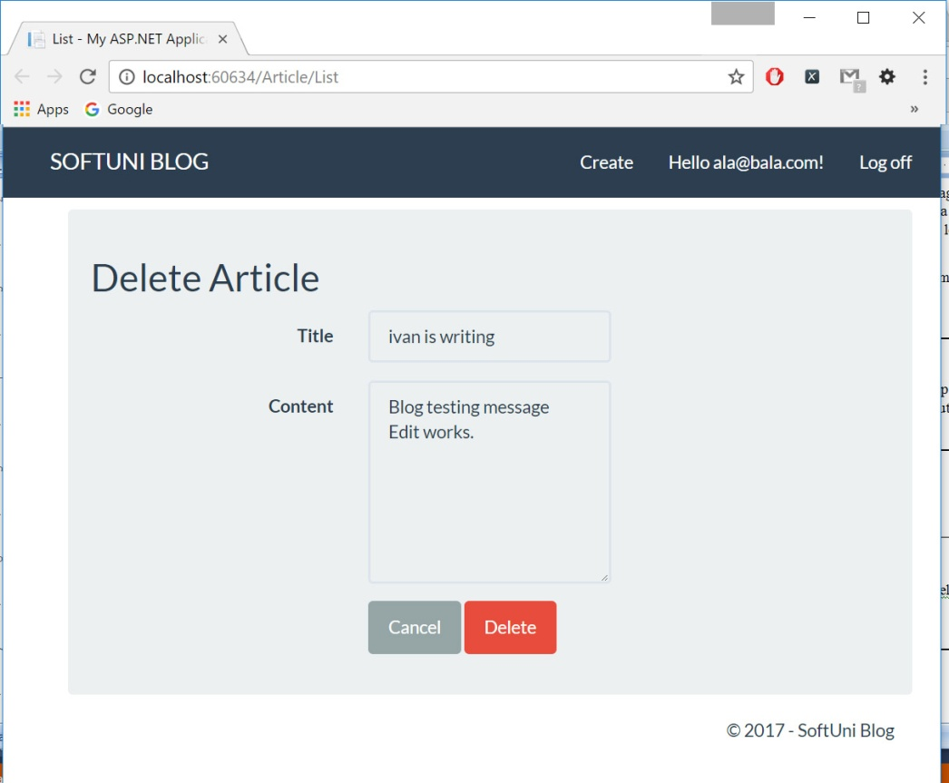

**Registered User Manage Info page** will contain header of Home Page with “Create”, user register email and “Log off” buttons. Under the header will be options for change of user credentials. User must be logged in to view this page. If he/she click on some of credentials to change will be redirect to the specific page.

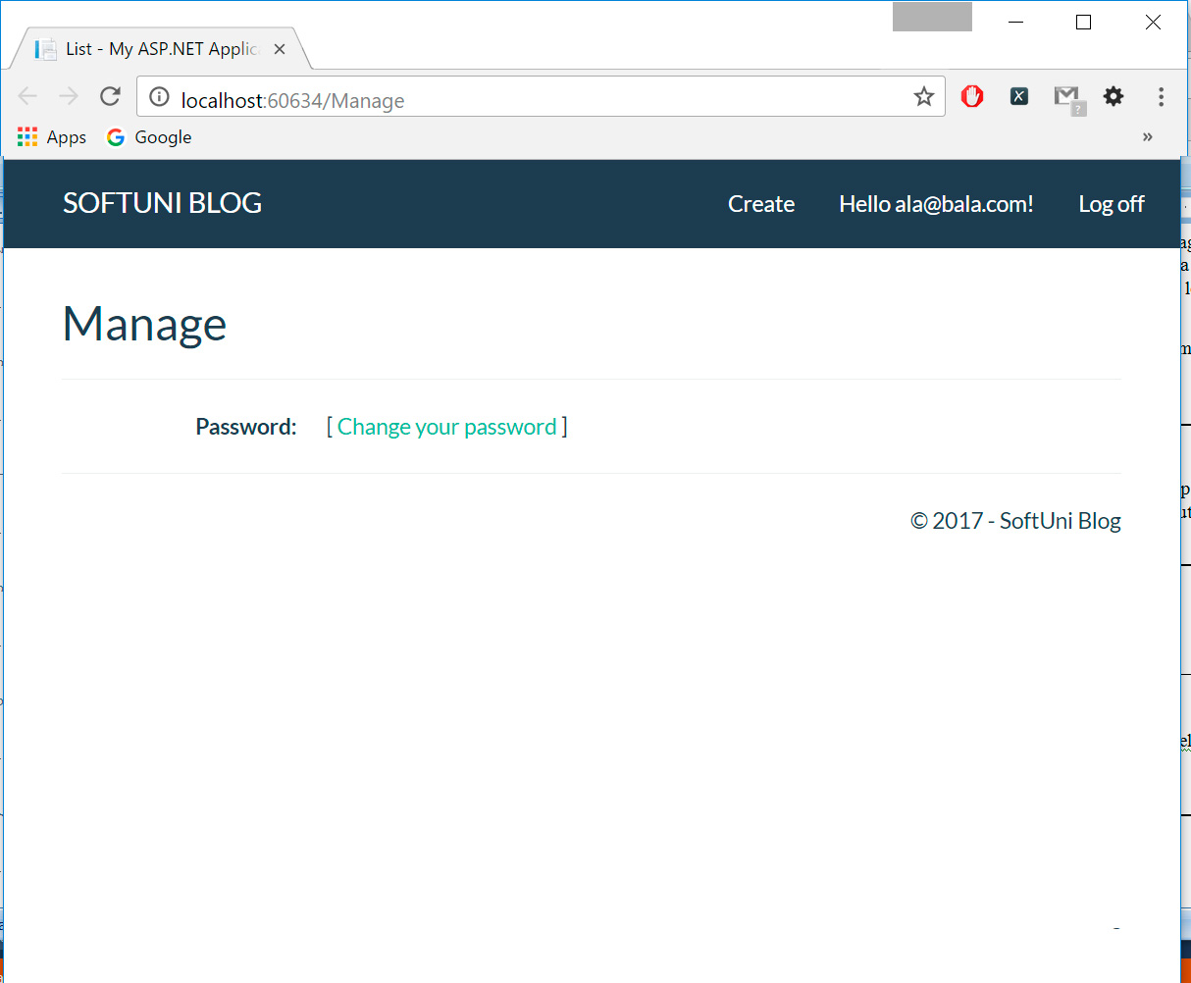

**Registered User Change Password page** will contain header of Home Page with “Create”, user register email and “Log off” buttons. Under the header will be form with input fields for old password, new password and confirmation of new password and button for password change. User must be logged in to view this page.

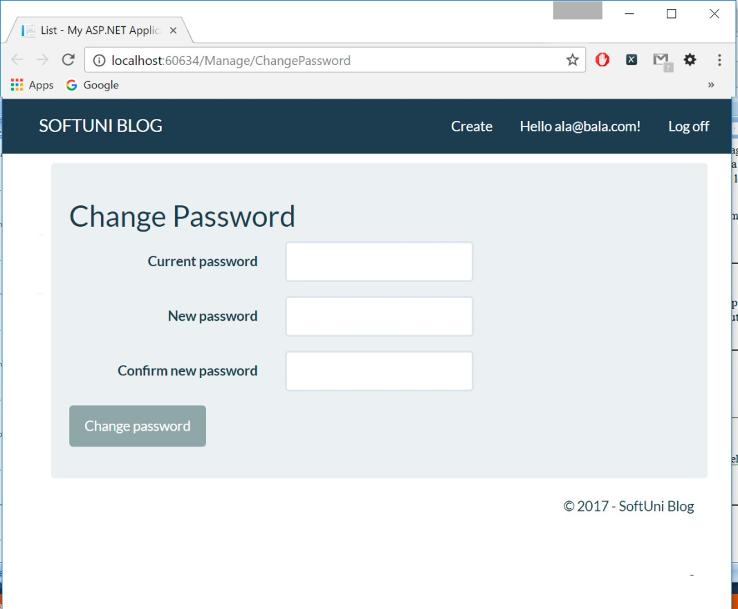

* 1. **Block Scheme of functionality**

**Enter into the Blog**

Write web address of the Blog Home page

**IF**

User has registration

User hasn’t registration

Guest user

Register user

Everyone can read all blog posts

User hasn’t registration

User has registration

**IF**

User can edit and delete his own credentials

User can edit and delete his own posts

User can only read posts

**Exit**

**the Blog**

* 1. **Non - functional Requirements**

***Loading of the Blog***

1. Loading/response time for Home Page and all other pages must **be in 1 sec.** according to connection speed.
2. When Home Page is loaded user must **see all blog posts** without delay.
3. When User enters the specific blog post he may see the **full post** version in new window.

***Registration into the Blog***

1. Everyone who wants to write in the Blog **must make a registration**.
2. After registration User may write, edit and delete **only his own posts**.
3. All information for registrations must be **stored and protected** for unauthorized change/usage.
4. All information of registered users must **stay consistent** for the lifetime of the Blog.

***Every logged user***

1. Can write, edit and delete **only his own posts**.
2. Can edit **his own** user information.

***The Blog system***

1. Can handles from 10000 to 20000 simultaneously reading users.
2. The number of registered users must be unlimited.
3. Every registration must be unique.
4. Every registration in the Blog should happen quickly and without delay.
5. Must be hosted on reliable hardware/software configuration.
   1. **Functional Requirements**

**For detailed information please check the document “ScenariosPassionFruit.xlsx”**